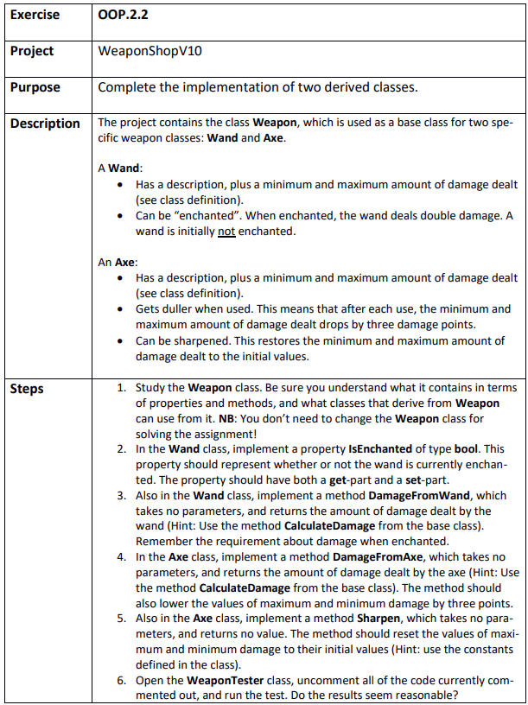

Step 1
WeaponShopV10.sln

Step 2

Step 3
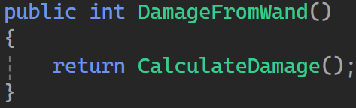

Step 4
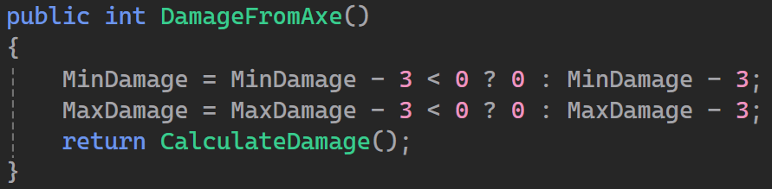

Step 5
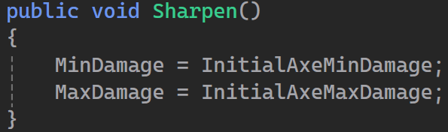

Step 6
Yeah

Step 7
They are essentially the same

